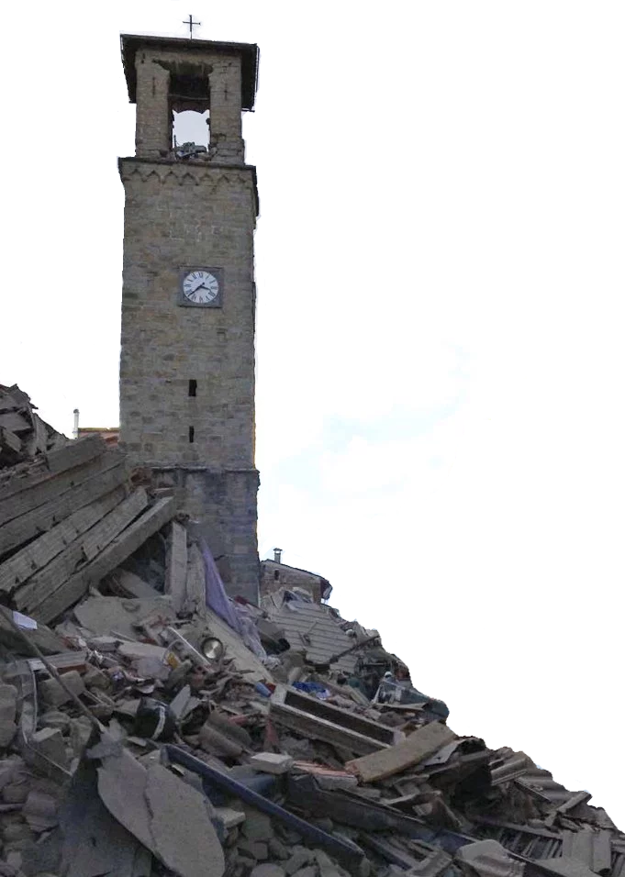
Mass for Italy
Following the devastation of a 6.2-magnitude earthquake in central Italy, we invite you to join us in prayer and giving.

Bi-Lingual English/Italian Mass for the Victims
Sunday, August 28, 2016
7:00 P.M.

At
Brooklyn’s Oldest Italian Church Community
Sacred Hearts – St. Stephen Catholic Parish
125 Summit Street, Brooklyn, NY 11231
Sacredhearts-ststephen.com
718-596-7750

A Special Collection will be taken at this Mass
to support the relief efforts
in those towns hit by the earthquake.

